1NF

All the multivalued attributes are put into separate rows. Example for phone and email.

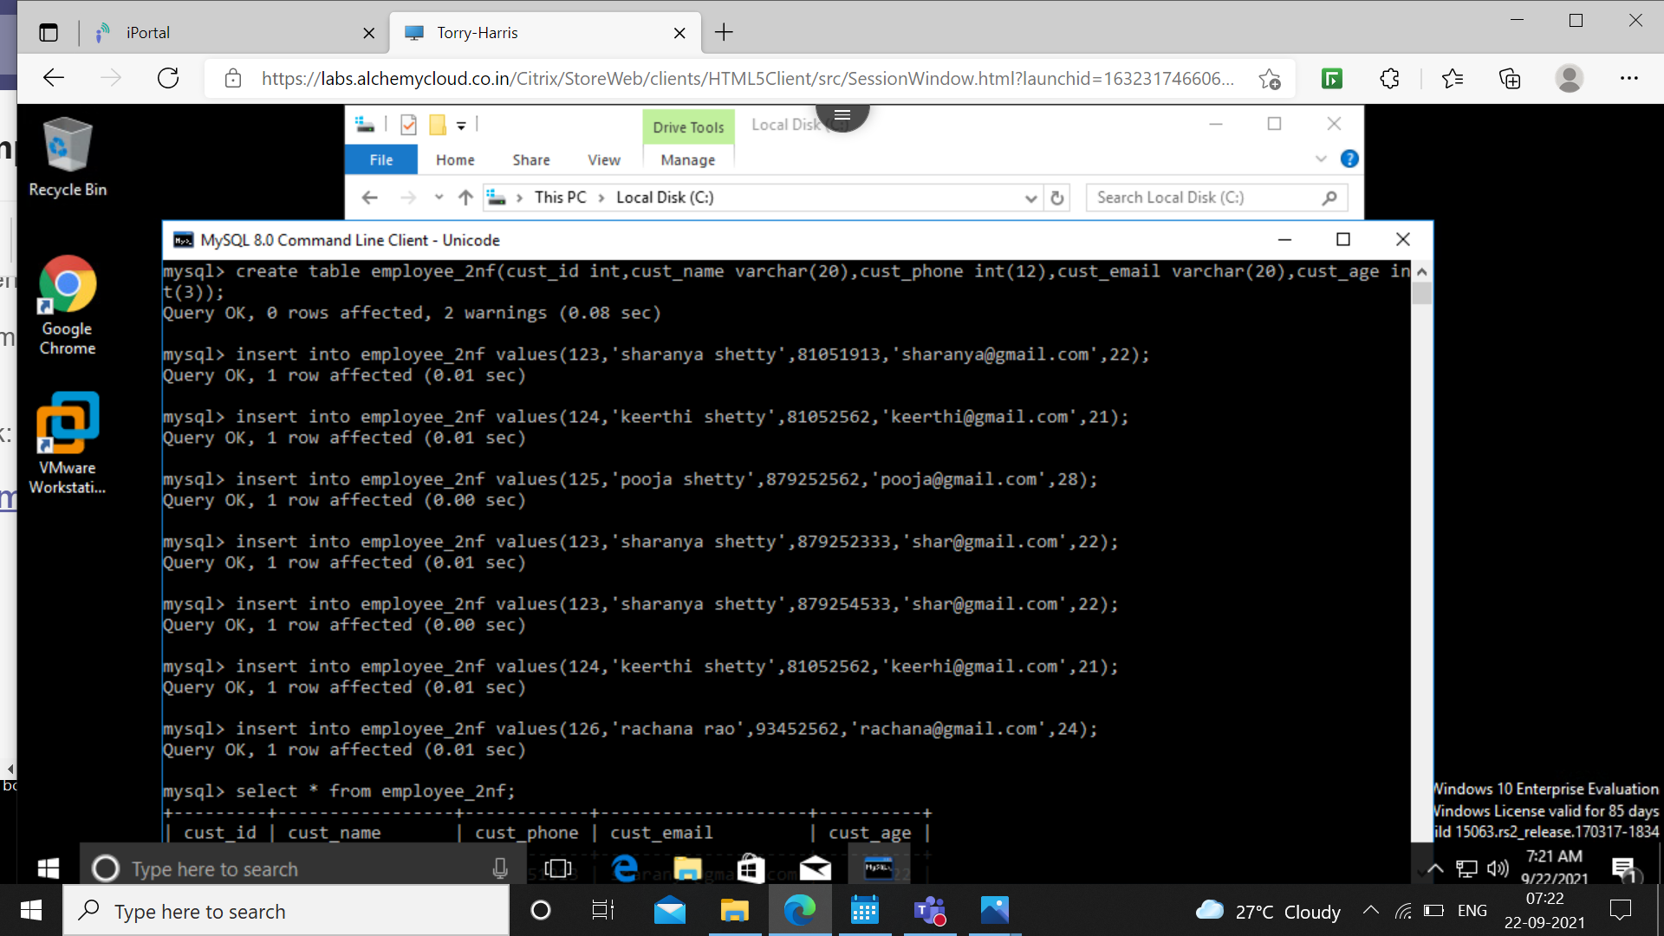

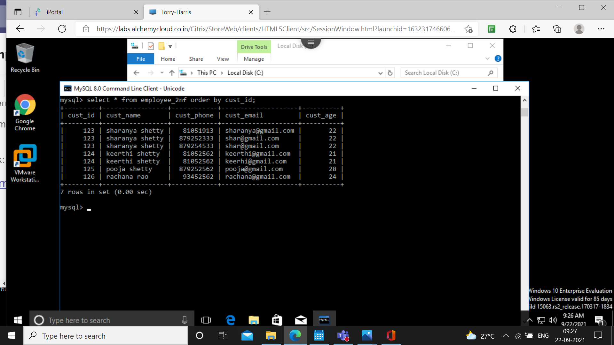

2NF

All non-key attributes are made fully functionally dependent on primary key.

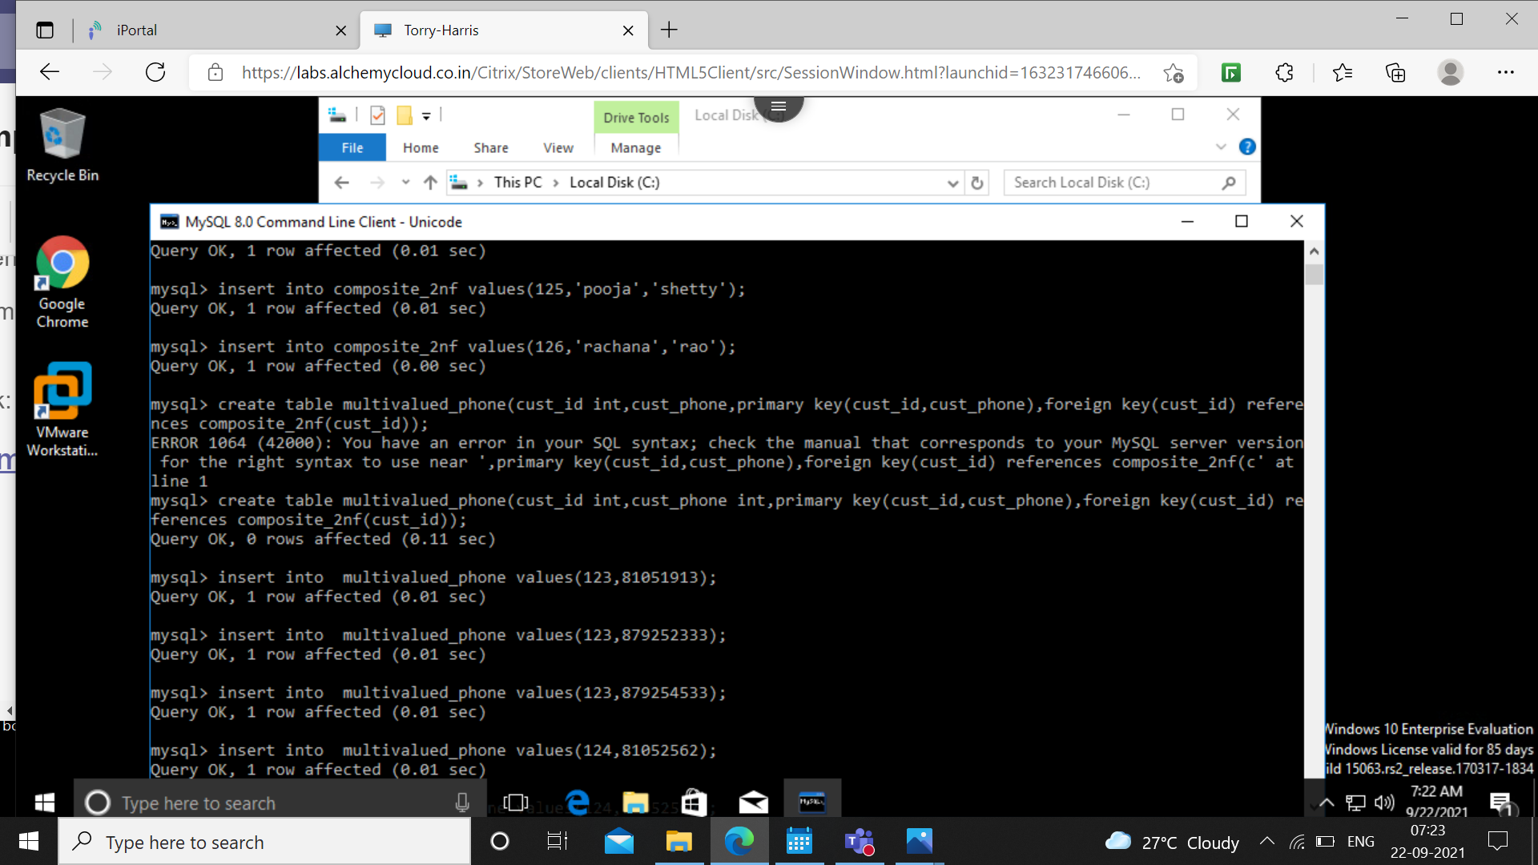

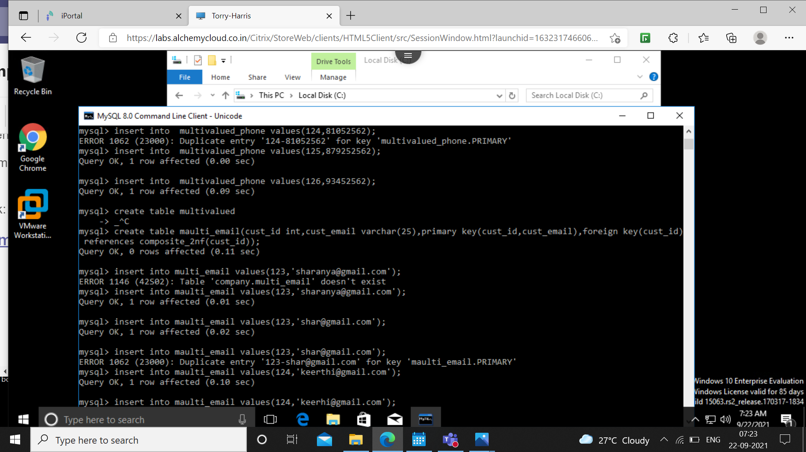

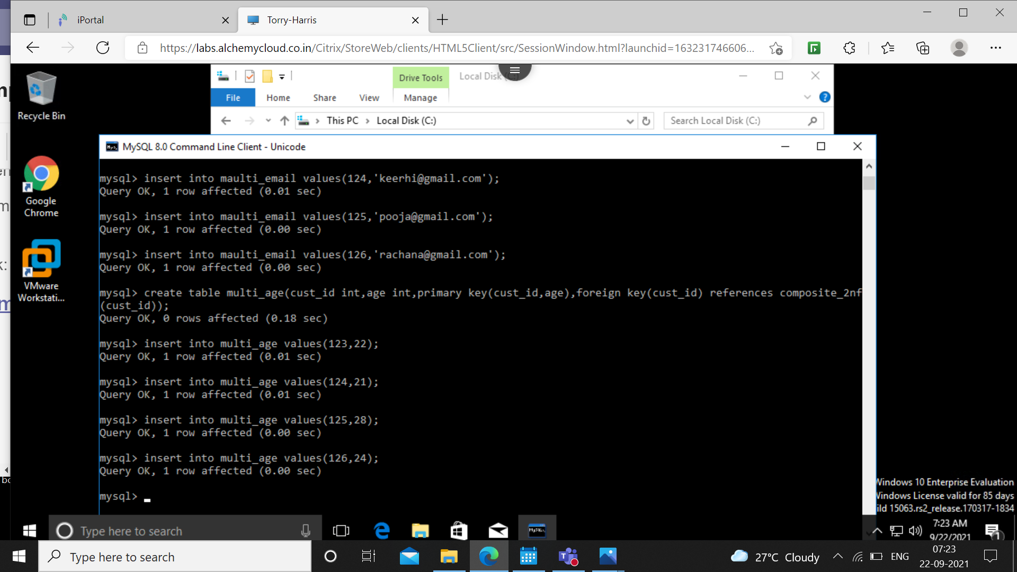

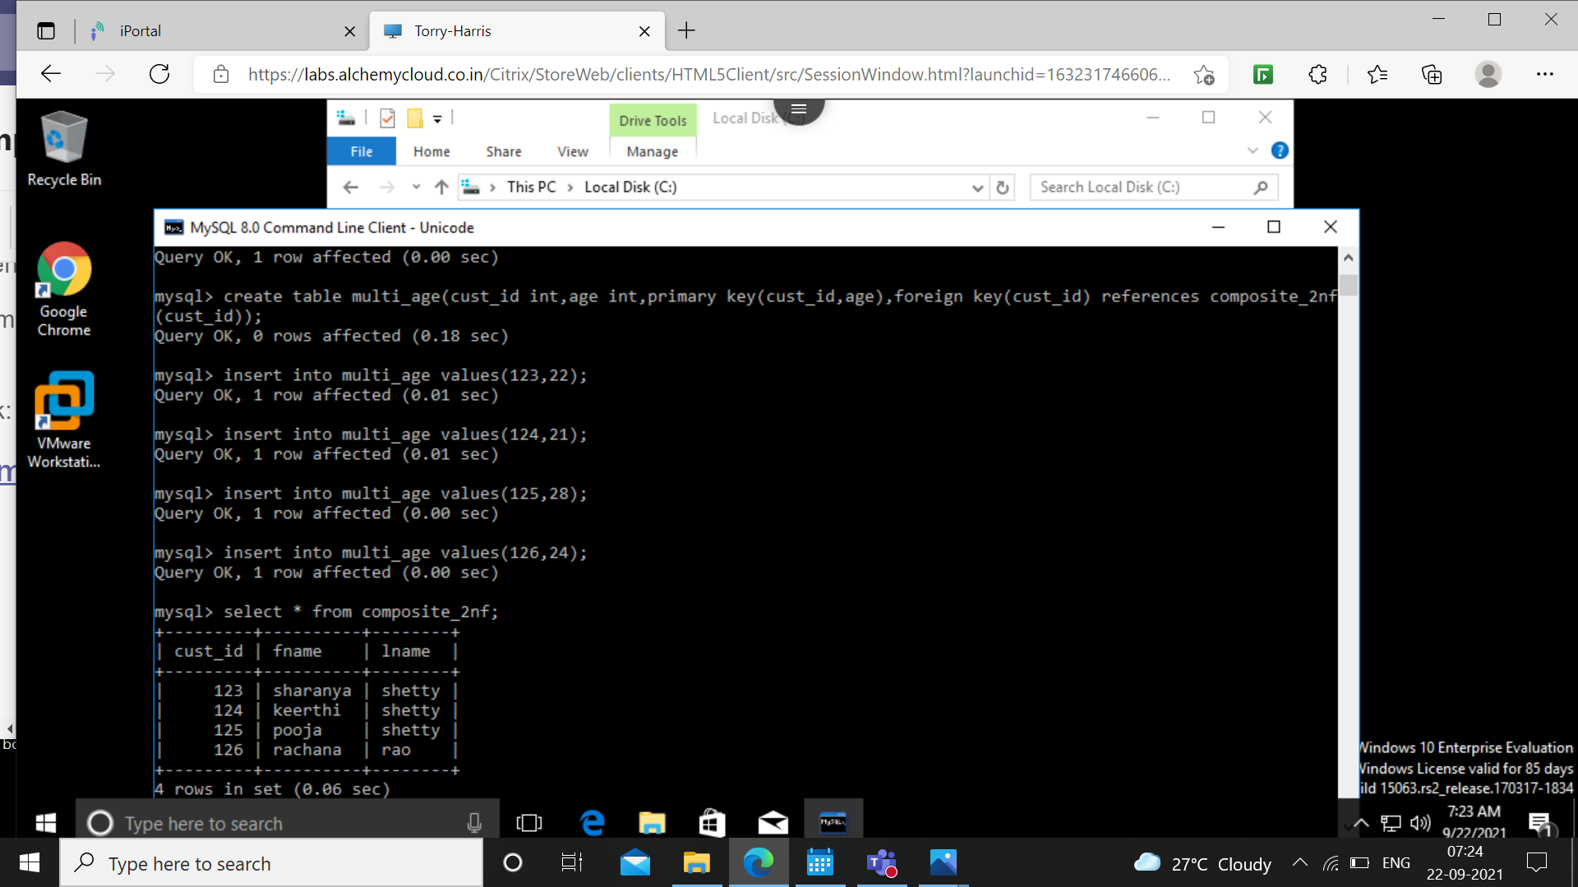





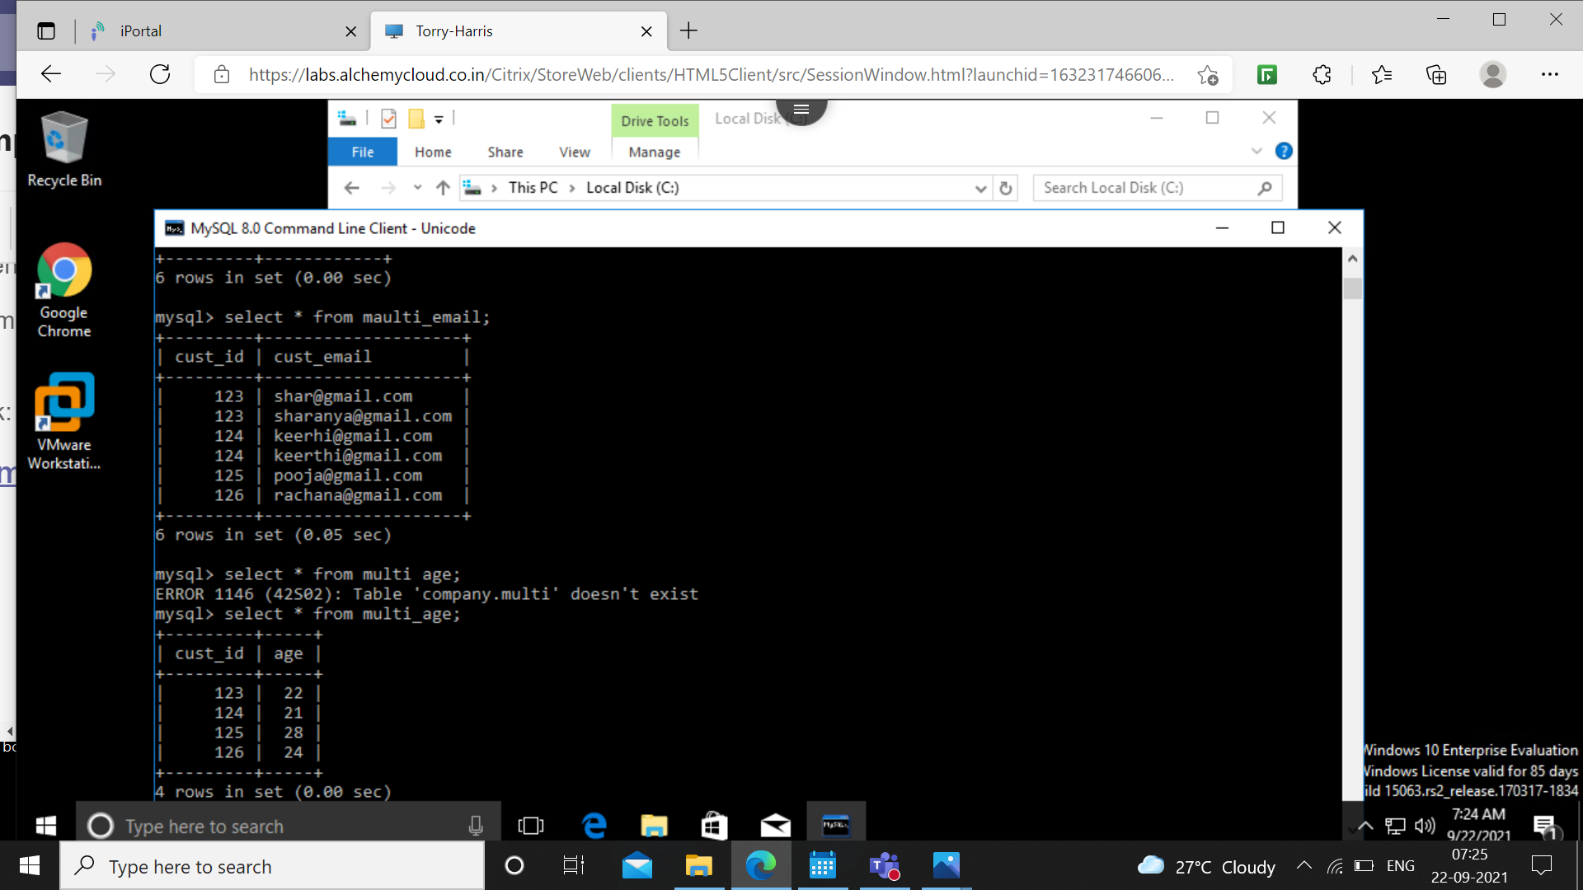

3NF

Transitive dependency is removed. Here, name, phone, country depends on id and country code depends on country. So, country code is transitively dependent on id. So, the table (id, name, phone, country, country code) is decomposed into (id, name, phone, country) and (country, country code).

